Title of Project
Project submitted to the
School of Engineering & Technology, BML Munjal University
for the partial fulfilment of the requirements to award the degree of
Bachelor of Technology
In
Computer Science and Engineering
School of Engineering and Technology
Submitted by
Full Name (Enrolment No)

Under the Guidance of
Name of Faculty
BML Munjal University
Kapriwas, Haryana– 122413
[May, 2026]

Certificate
Date: 11/28/2024
This is to certify that the work present in this Project entitled “Title” has been carried out by Full name under my/our supervision. The work is genuine, original, and suitable for submission to the BML Munjal University for the award of Bachelor of Technology in School of Engineering and Technology.

Supervisor
Prof. / Dr. Faculty Name
Designation:

Table of Contents
Sl.No. | Topic | Page No.
1 | Certificate | 2
2 | Table of Contents | 3
3 | Abstract | 4
4 | Abbreviations | 5
5 | List of Tables | 6
6 | List of Figures | 7
7 | Introduction | 8
8 | Problem Statement | 9
9 | Methodology | 10
10 | Discussion | 12
11 | Concluding Remarks | 13
12 | Societal Relevance | 13
13 | Future Scope | 14
14 | Team Details and Contribution | 14
15 | References | 15

Abstract (max 2 paragraphs)
This research focuses…………………………………………….…………………………….

This method was implemented in ……………………………………………….………….. The effectiveness of this method was evaluated using ………………………………………... The results shows that this approach maintains the ………………………………….………..

Abbreviations
Shot form | Full Form

List of Tables
Table 1.
Table 2.

List of Figures
Figure 1. Fig1:
Figure 2. Fig2:

Introduction
As human activities increasingly transition to the digital realm, the use of both private and public networks has grown significantly. This rise in digitalization has also led to an increase in cybercrime, highlighting the critical need for robust security measures to safeguard data transactions and information storage from potential hacker attacks. To address these challenges, methods such as cryptography and data hiding are widely employed to protect sensitive information.
While cryptography and data hiding share the common goal of enhancing security, they are distinct disciplines. Data hiding, in particular, is divided into two major branches: steganography and watermarking. Each of these techniques, along with cryptography, serves unique purposes and possesses distinct characteristics. Steganography, for instance, focuses on securing information by embedding it within a cover medium in a way that conceals its presence. This method aims to deceive adversaries or hackers by ensuring that the hidden data remains undetectable.

Methodology
- Design (ER Diagram, Schema, Normalization)

- Implementation

- Algorithm:
Input:
Output:
Step 1:
Step 2:

- Discussion/Results/Observations
Sub heading:
The images below show the original cover image (left) and the stego image (right)..

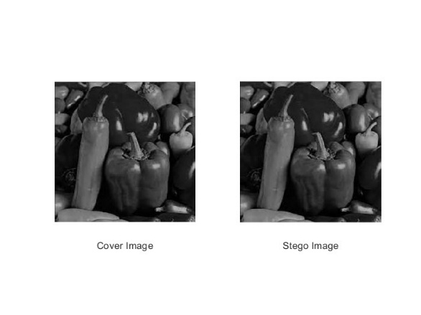
Fig 1: Caption

Table 1. Caption [ref].
Cover Images | Proposed MSE | Reference  MSE [2]
Lena (512X512)
Cameraman (256X256)
Babara (512X512)
Pepper (256X256)

Concluding Remarks

Any societal relevance of your work

Future scope (how would you like to expand this, if any plan)

- Team details and individual contribution

References
- Ref1.
- Ref2.

